Lab 3
--1
SELECT *
FROM passengers
WHERE first_name = last_name;
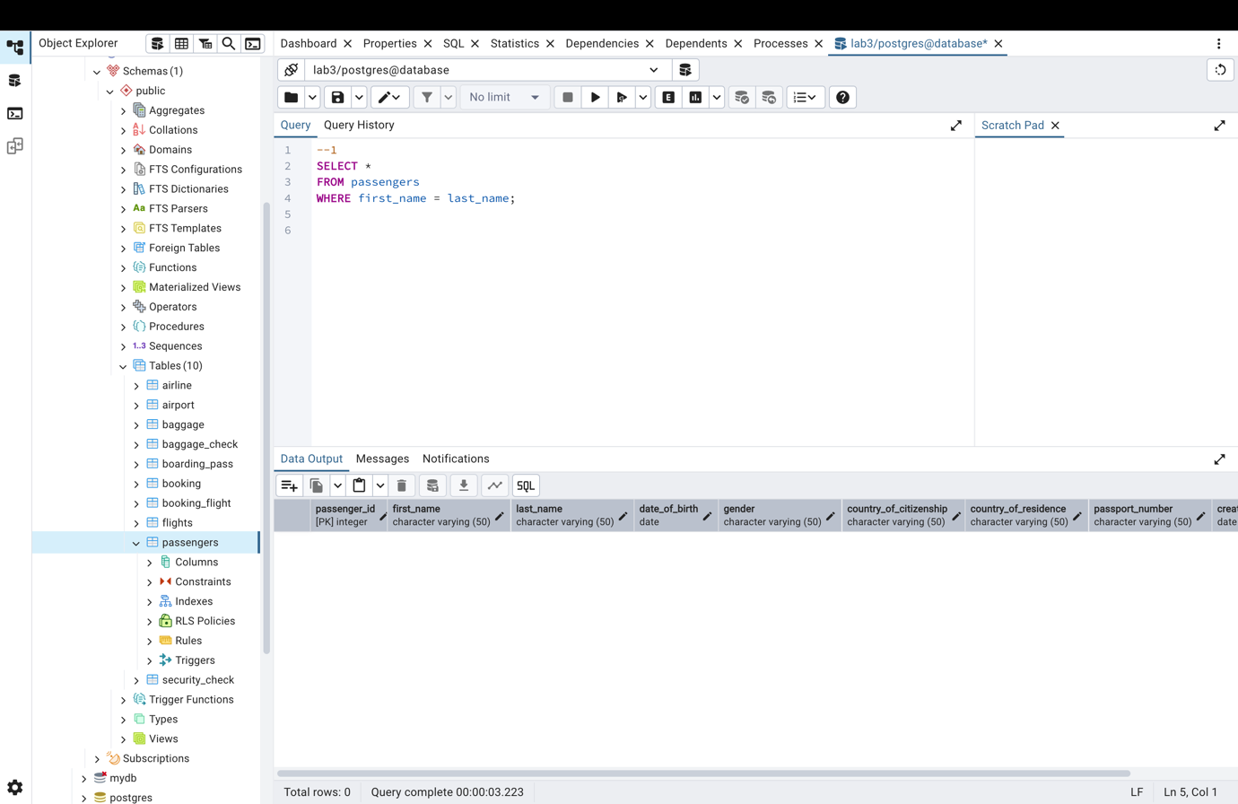
--2
SELECT DISTINCT last_name
FROM passengers;
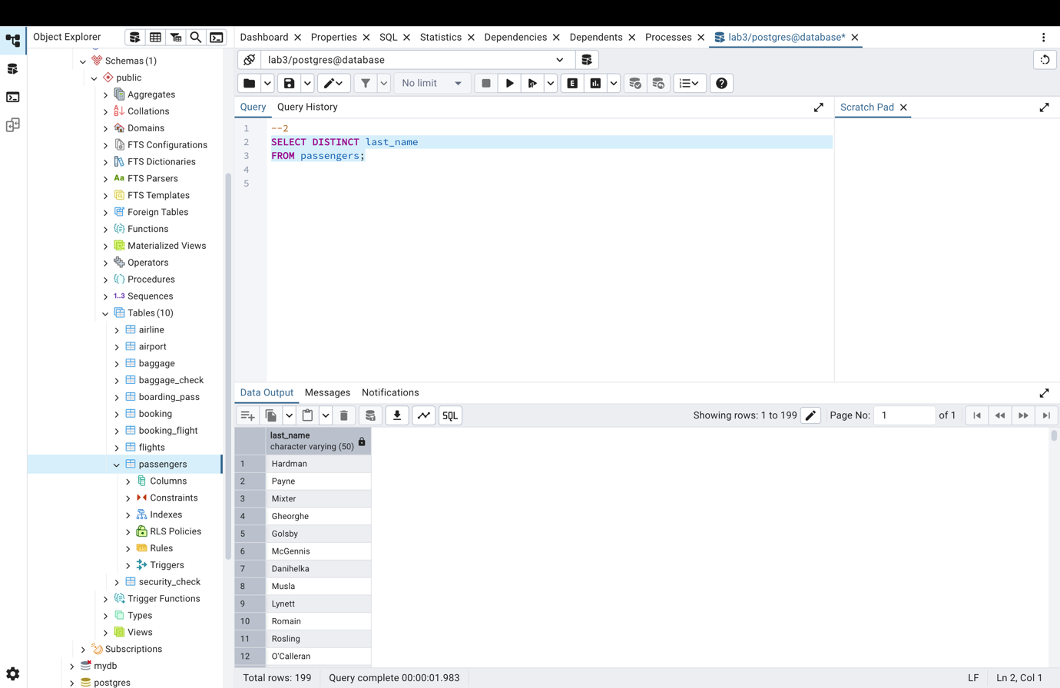

--3
SELECT * FROM passengers
WHERE gender = 'Male'
AND date_of_birth BETWEEN '1990-01-01' AND '2000-12-31';
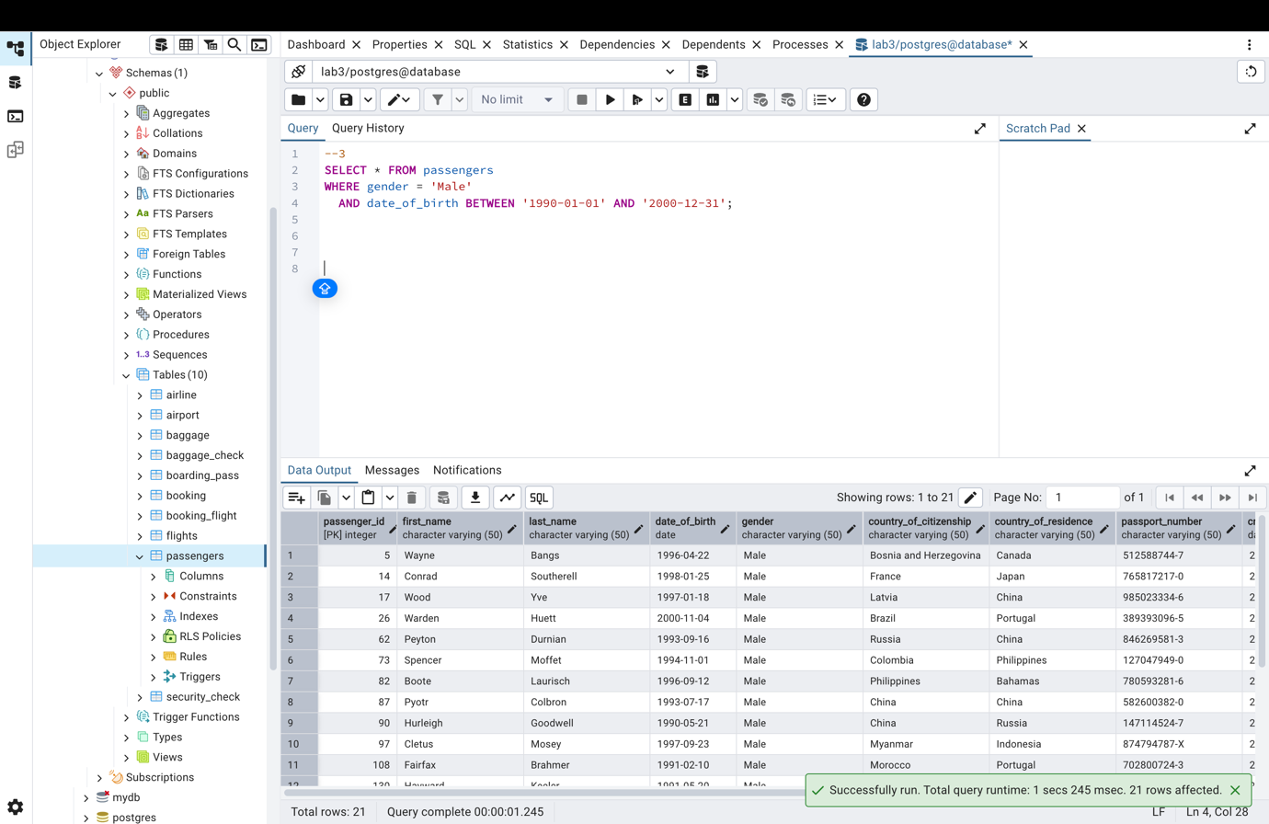

--4
SELECT DATE_TRUNC('month', created_at) AS month,
SUM(price) AS total_price
FROM booking
GROUP BY month
ORDER BY month;
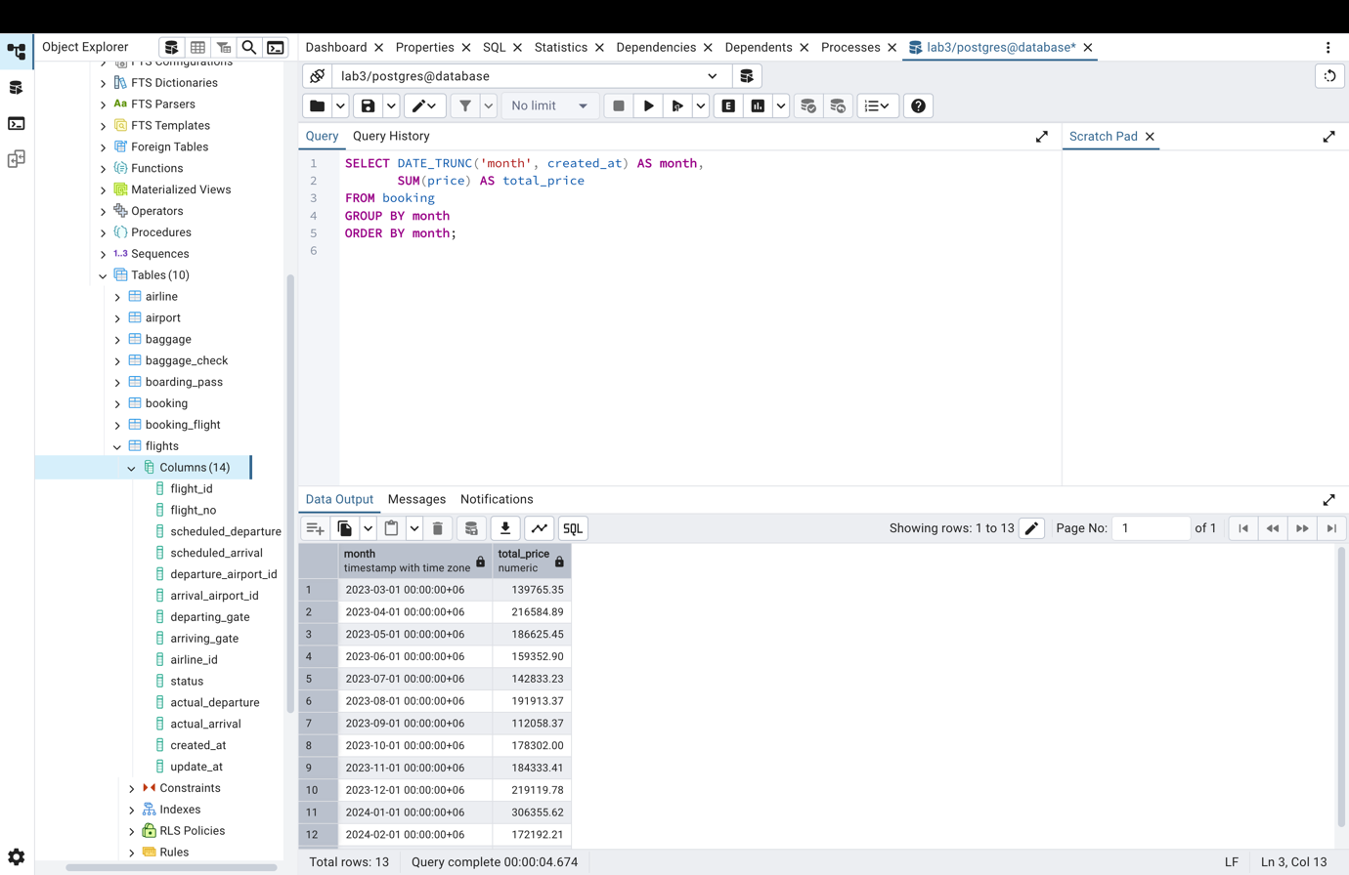
--5
SELECT * FROM flights where flight_no like 'CN%';
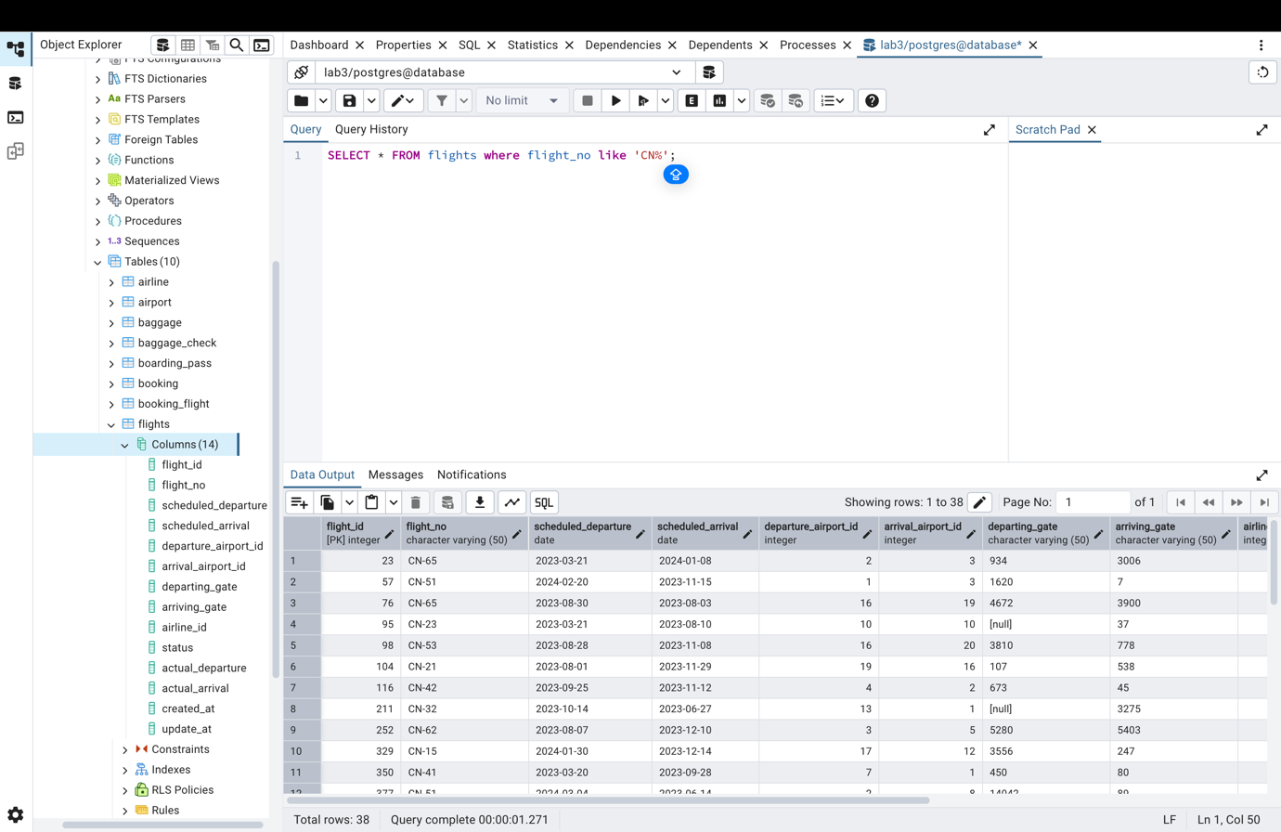
--6
SELECT *
FROM airline
WHERE airline_country IN ('France','Portugal','Poland')
AND created_at BETWEEN '2023-11-01' AND '2024-03-31';
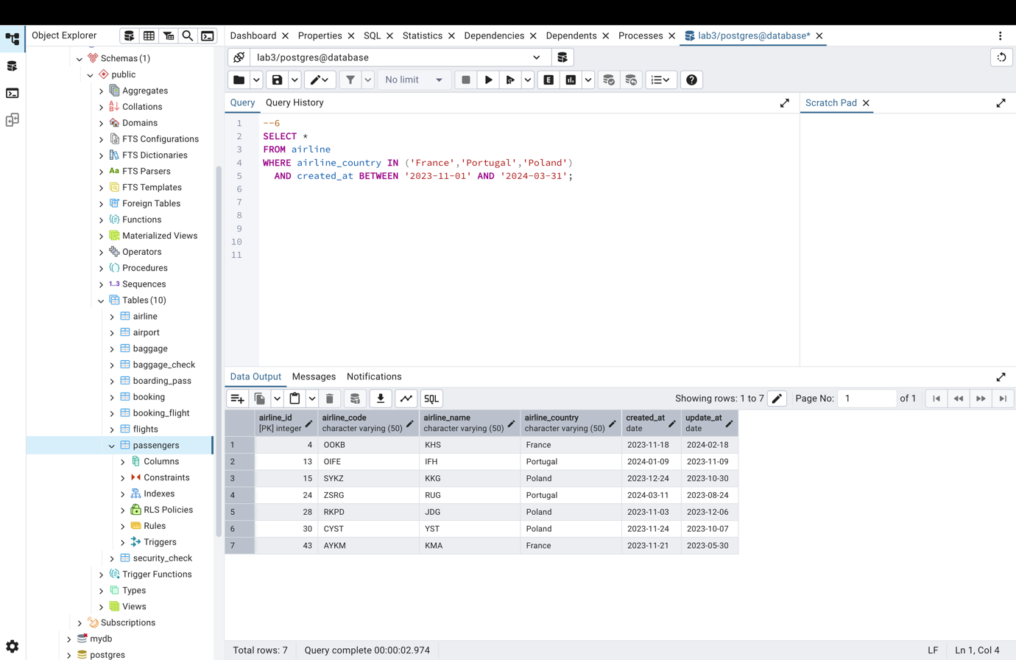
--7
SELECT airline_name FROM airline WHERE airline_country = 'Kazakhstan';
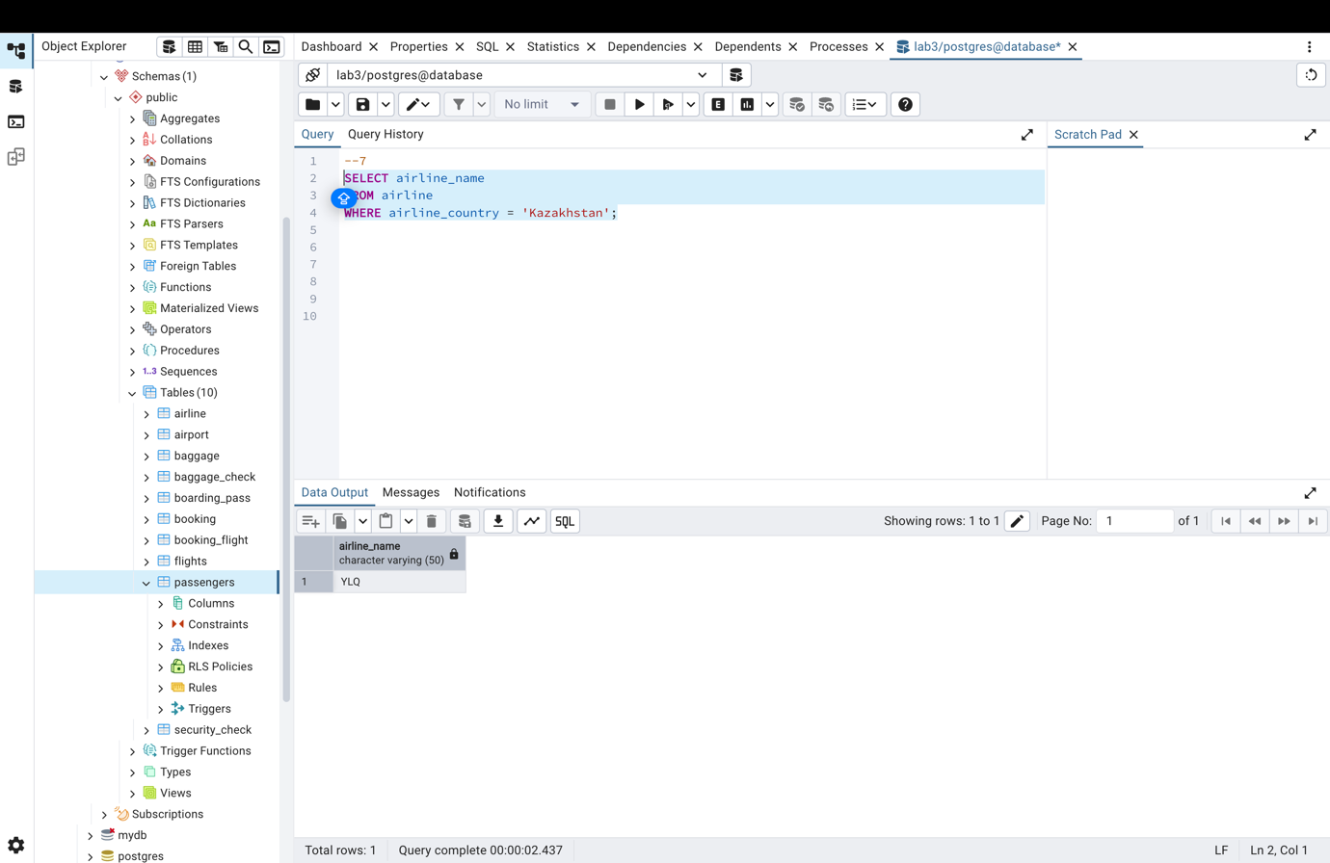
--8
UPDATE booking
SET price = price * 0.9
WHERE created_at < '2023-11-01';
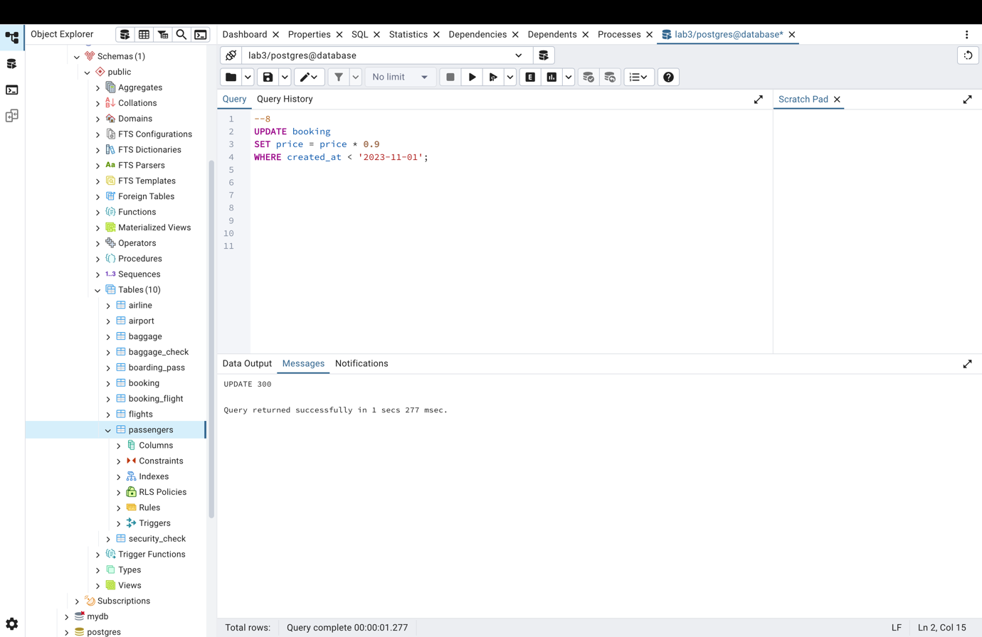

--9
SELECT * FROM baggage WHERE weight_in_kg > 25 ORDER BY weight_in_kg DESC LIMIT 3;
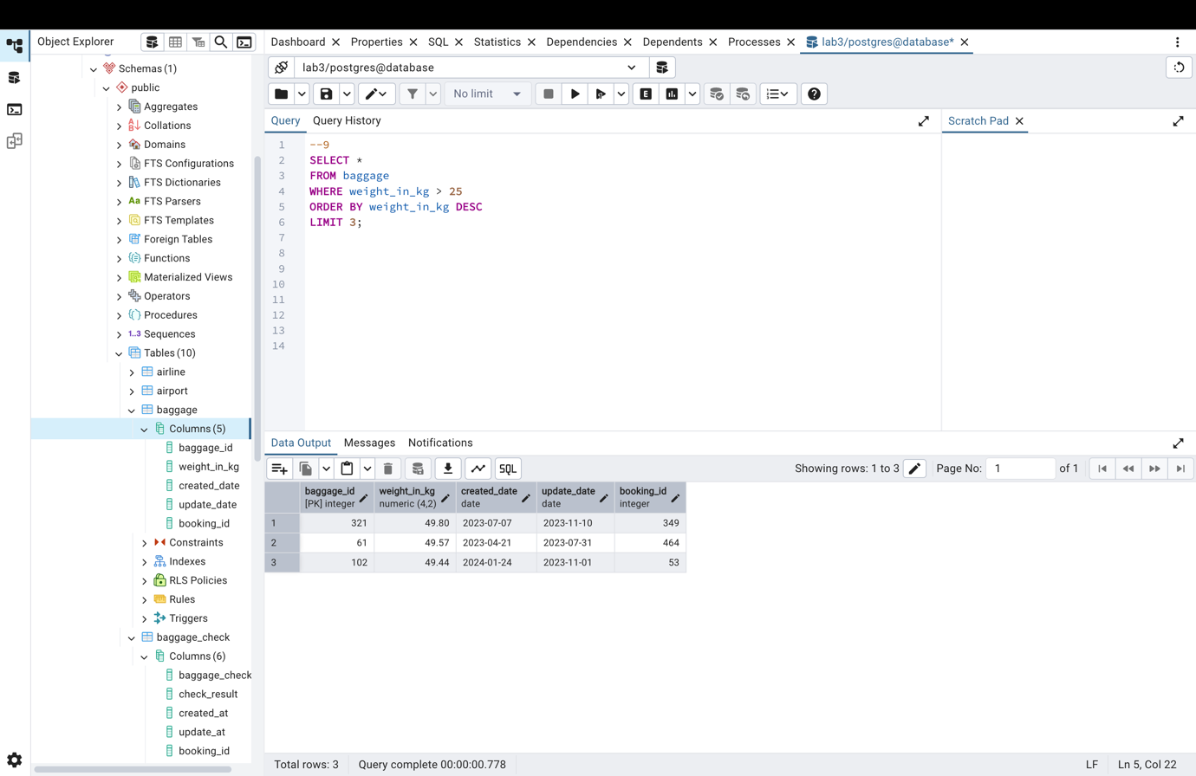

--10
SELECT first_name, last_name
FROM passengers
ORDER BY date_of_birth DESC
LIMIT 1;
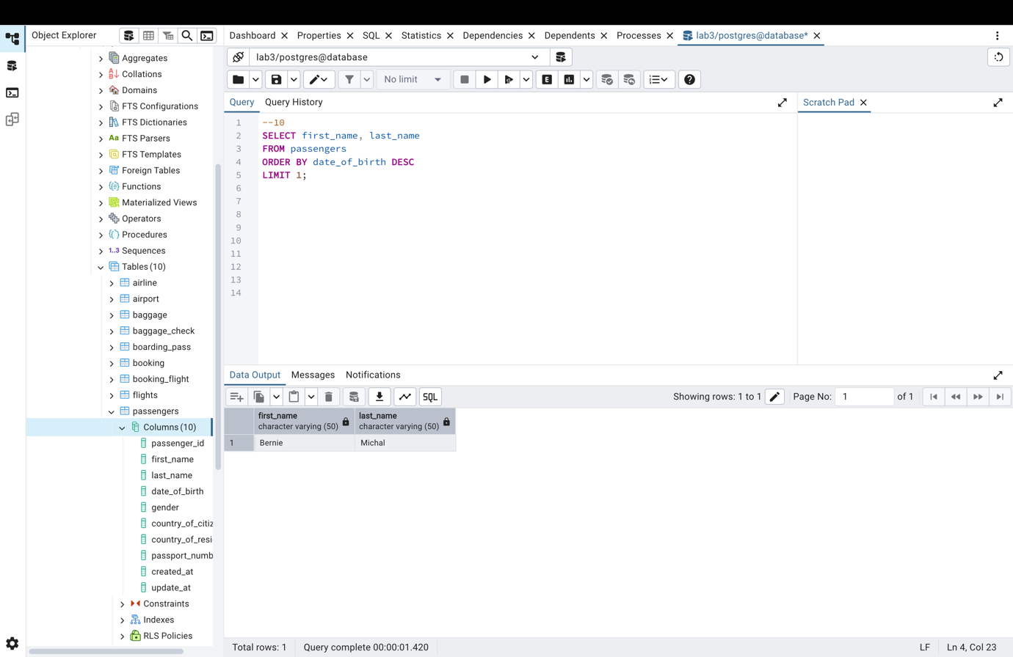

--11
SELECT booking_platform, MIN(price) AS cheapest_price
FROM booking
GROUP BY booking_platform;
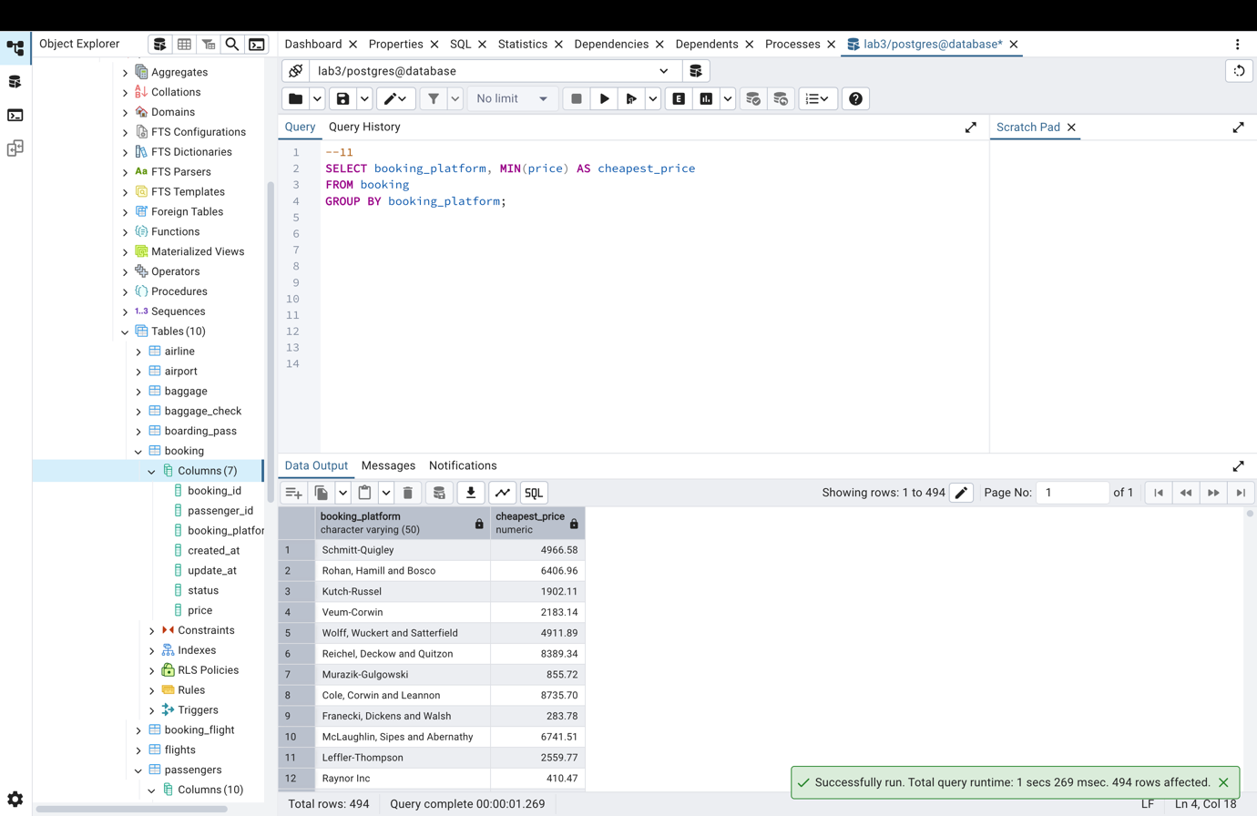

--12
SELECT *
FROM airline
WHERE airline_code ~ '[0-9]';
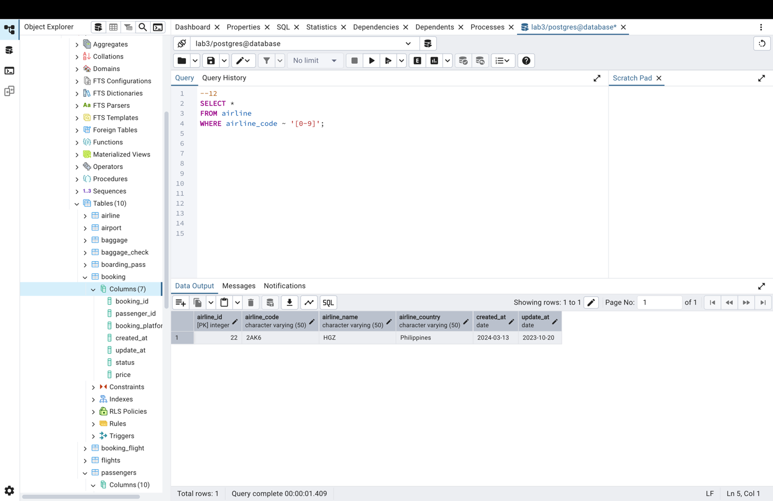
--13
SELECT *
FROM airline
ORDER BY created_at DESC
LIMIT 5;
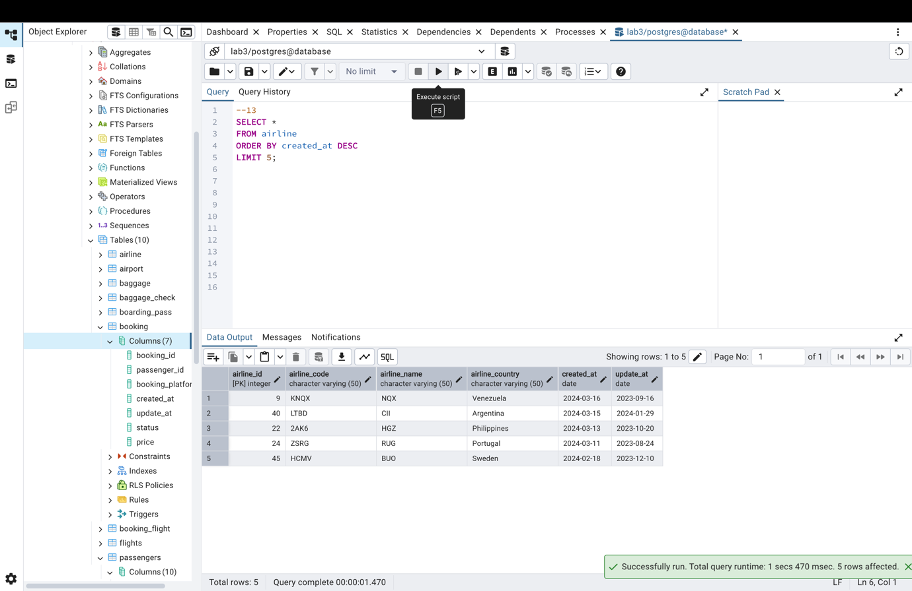
--14
SELECT *
FROM baggage_check
WHERE booking_id BETWEEN 200 AND 300
AND check_result <> 'Checked';
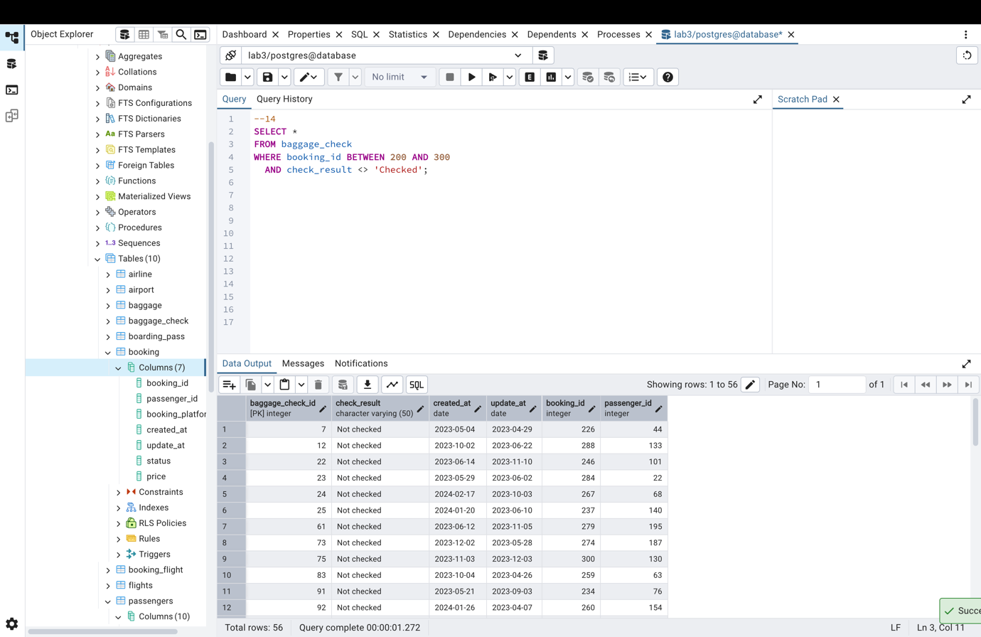
--15
SELECT *
FROM baggage_check
WHERE DATE_TRUNC('month', created_at) = DATE_TRUNC('month', update_at)
AND update_at < created_at;
